Test Case: tc001_SPX_Dev5_Crear_Nueva_Linea_Requisicion_Spot_Tipo_Cobro_CC
Step 1 - Enter username and password and click to button Enter : Credentials Entered
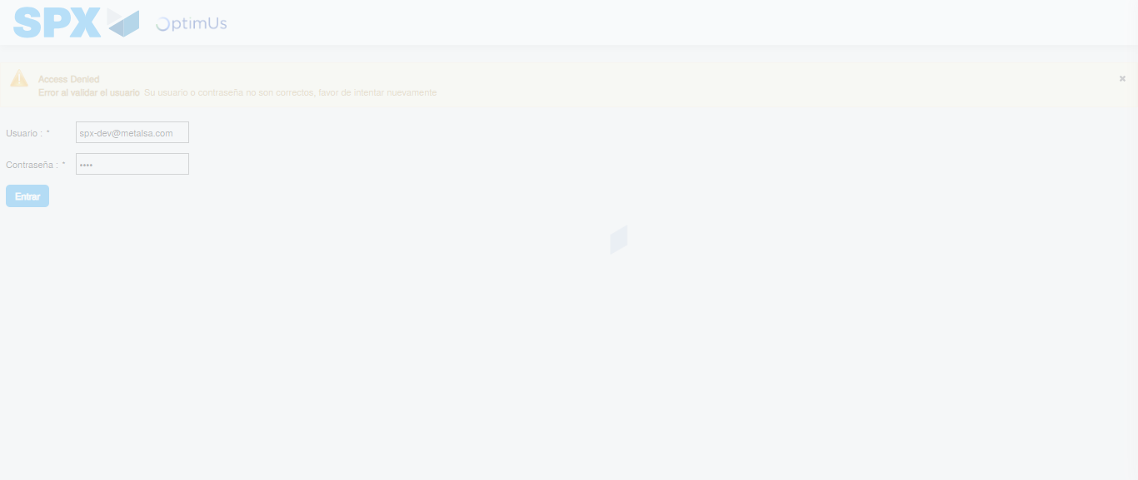Image file-name: QC_Testing-tc001_SPX_Dev5_Crear_Nueva_Linea_Requisicion_Spot_Tipo_Cobro_CC-1790176197202

Step 2 - Select to UEN and Access to Spot Buy Requisitions : UEN Correctly selected and Correct access
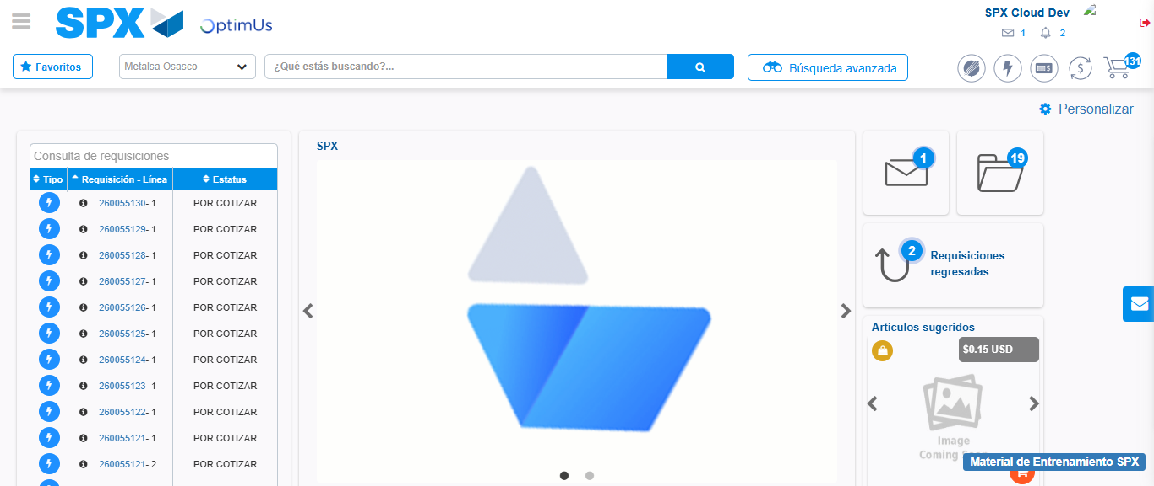Image file-name: QC_Testing-tc001_SPX_Dev5_Crear_Nueva_Linea_Requisicion_Spot_Tipo_Cobro_CC-1790176220883

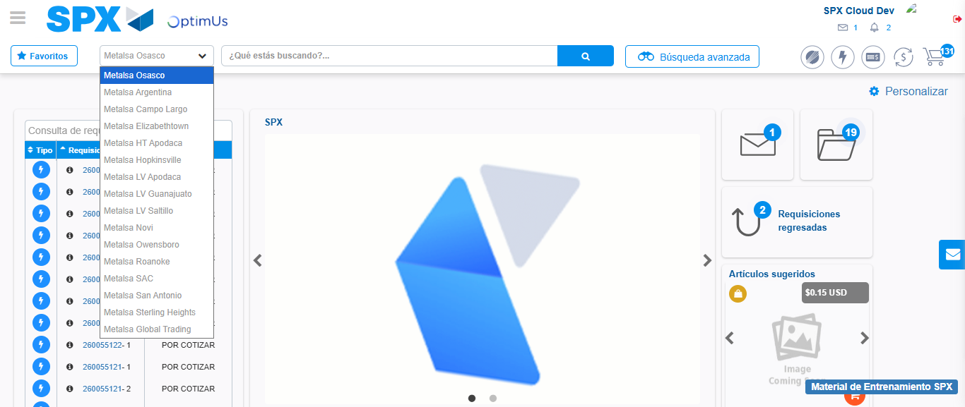Image file-name: QC_Testing-tc001_SPX_Dev5_Crear_Nueva_Linea_Requisicion_Spot_Tipo_Cobro_CC-1790176221357

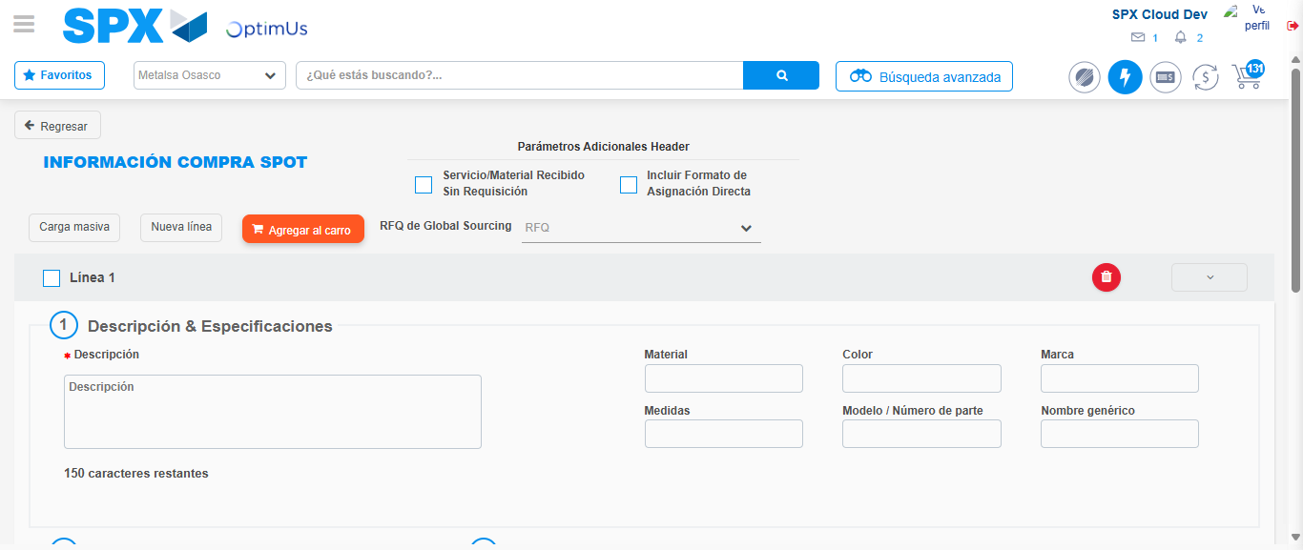Image file-name: QC_Testing-tc001_SPX_Dev5_Crear_Nueva_Linea_Requisicion_Spot_Tipo_Cobro_CC-1790176225880

Step 3 - Data Capture Spot Buy Requisition: Data captured correctly
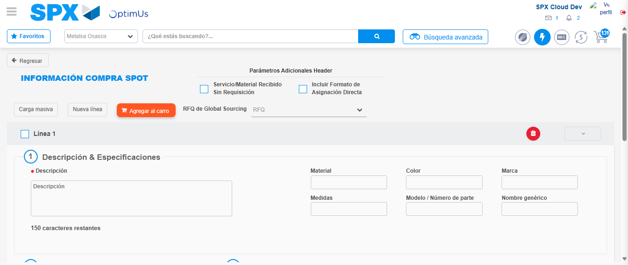Image file-name: QC_Testing-tc001_SPX_Dev5_Crear_Nueva_Linea_Requisicion_Spot_Tipo_Cobro_CC-1790176226133

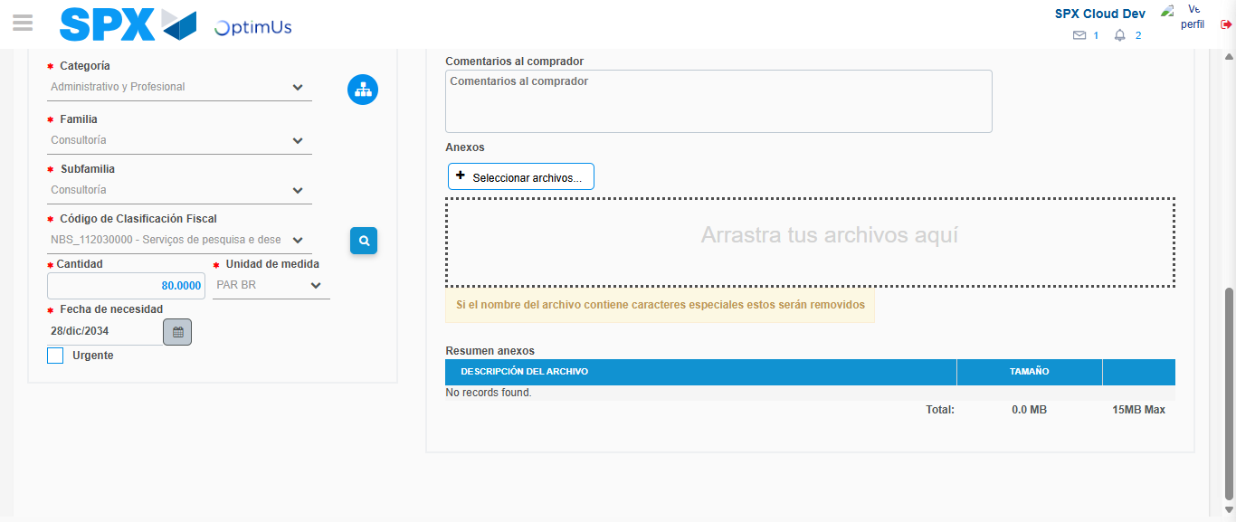Image file-name: QC_Testing-tc001_SPX_Dev5_Crear_Nueva_Linea_Requisicion_Spot_Tipo_Cobro_CC-1790176249518

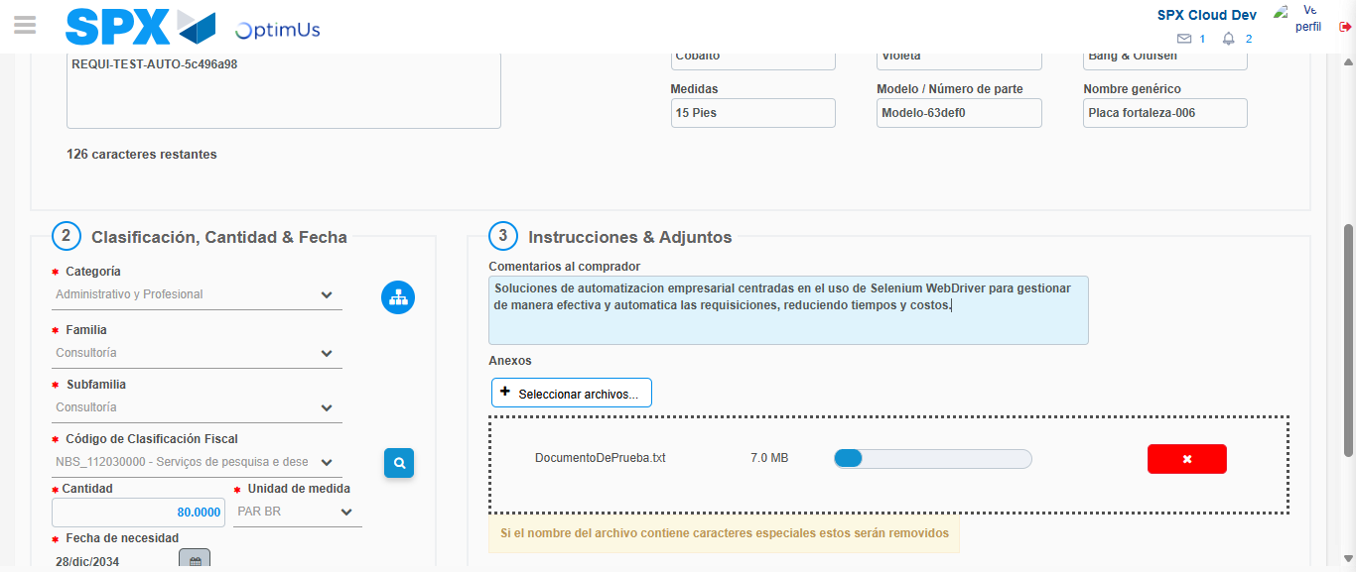Image file-name: QC_Testing-tc001_SPX_Dev5_Crear_Nueva_Linea_Requisicion_Spot_Tipo_Cobro_CC-1790176250442

Step 4 - Add new line and data capture second line: Line add correctly
Image file-name: QC_Testing-tc001_SPX_Dev5_Crear_Nueva_Linea_Requisicion_Spot_Tipo_Cobro_CC-1790176226133

Image file-name: QC_Testing-tc001_SPX_Dev5_Crear_Nueva_Linea_Requisicion_Spot_Tipo_Cobro_CC-1790176249518

Image file-name: QC_Testing-tc001_SPX_Dev5_Crear_Nueva_Linea_Requisicion_Spot_Tipo_Cobro_CC-1790176250442

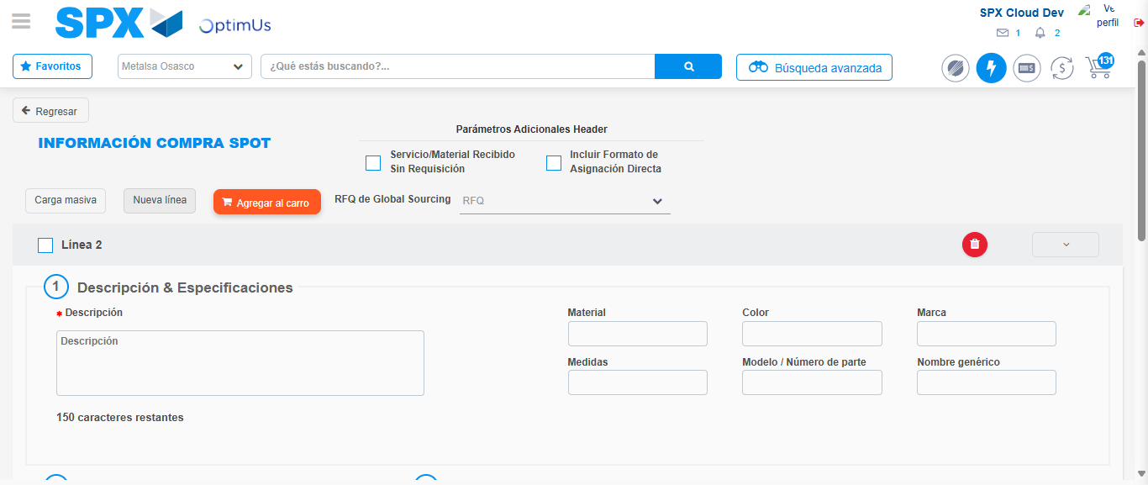Image file-name: QC_Testing-tc001_SPX_Dev5_Crear_Nueva_Linea_Requisicion_Spot_Tipo_Cobro_CC-1790176252786

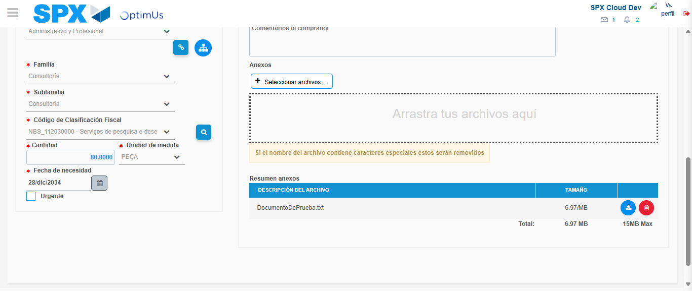Image file-name: QC_Testing-tc001_SPX_Dev5_Crear_Nueva_Linea_Requisicion_Spot_Tipo_Cobro_CC-1790176268759

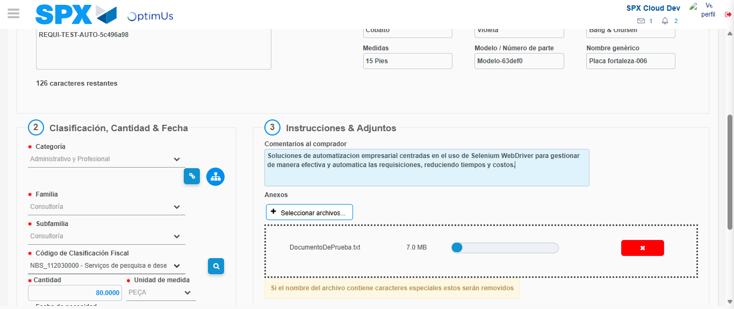Image file-name: QC_Testing-tc001_SPX_Dev5_Crear_Nueva_Linea_Requisicion_Spot_Tipo_Cobro_CC-1790176269491

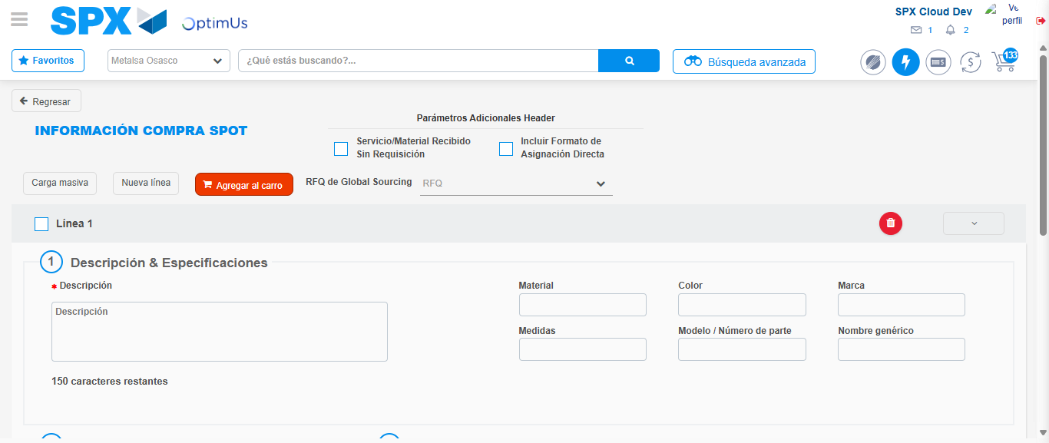Image file-name: QC_Testing-tc001_SPX_Dev5_Crear_Nueva_Linea_Requisicion_Spot_Tipo_Cobro_CC-1790176278405

Step 8 - Return to Main Page SPX : Return to Main Page SPX
Image file-name: QC_Testing-tc001_SPX_Dev5_Crear_Nueva_Linea_Requisicion_Spot_Tipo_Cobro_CC-1790176220883

Image file-name: QC_Testing-tc001_SPX_Dev5_Crear_Nueva_Linea_Requisicion_Spot_Tipo_Cobro_CC-1790176221357

Image file-name: QC_Testing-tc001_SPX_Dev5_Crear_Nueva_Linea_Requisicion_Spot_Tipo_Cobro_CC-1790176225880

Image file-name: QC_Testing-tc001_SPX_Dev5_Crear_Nueva_Linea_Requisicion_Spot_Tipo_Cobro_CC-1790176280627

Image file-name: QC_Testing-tc001_SPX_Dev5_Crear_Nueva_Linea_Requisicion_Spot_Tipo_Cobro_CC-1790176280789

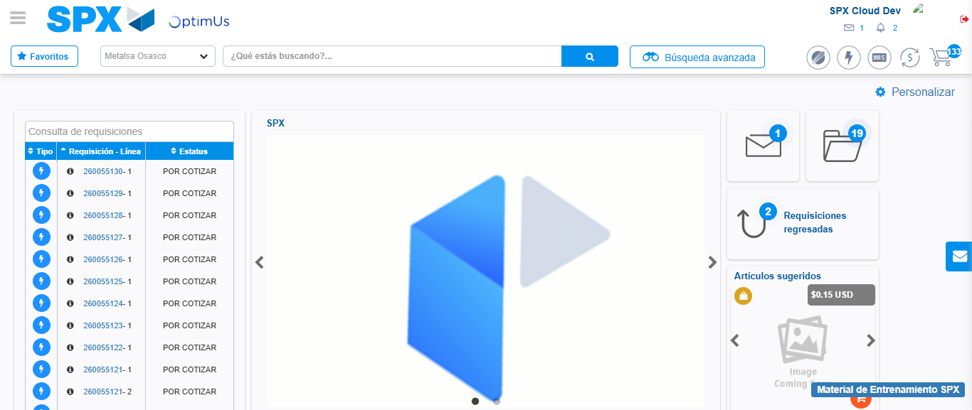Image file-name: QC_Testing-tc001_SPX_Dev5_Crear_Nueva_Linea_Requisicion_Spot_Tipo_Cobro_CC-1790176302060

Step 9 - Log Out : Log Out SPX
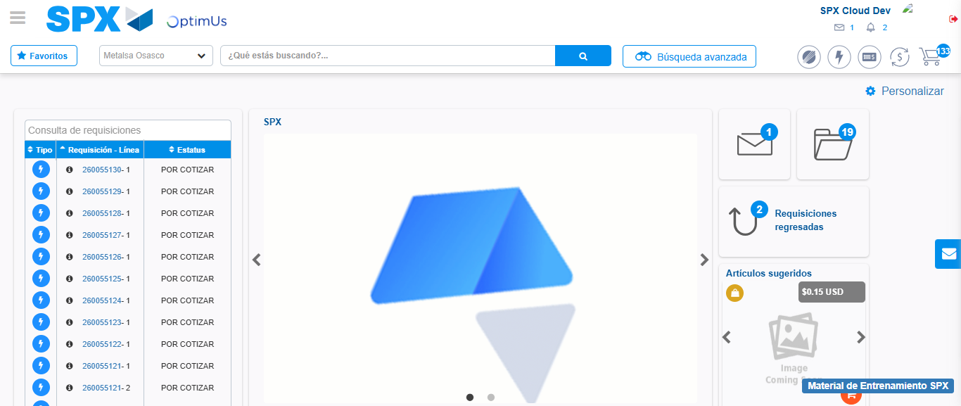Image file-name: QC_Testing-tc001_SPX_Dev5_Crear_Nueva_Linea_Requisicion_Spot_Tipo_Cobro_CC-1790176302473

